**Student Habit vs Academic Performance**

**Problem**

Educational institutions and researchers are constantly seeking ways to understand what factors most influence students' academic performance. While intelligence and curriculum are important, daily habits such as sleep, study time, diet, mental well-being, and extracurricular involvement can also play a major role.

However, identifying which lifestyle patterns have the greatest impact on final exam performance can be challenging without structured analysis. This project aims to solve that by using machine learning techniques to uncover and quantify these relationships.

**Objective**

The goal of this project is to:

* Build a predictive model that estimates a student’s final exam score based on lifestyle-related features.
* Understand how habits like study time, sleep duration, social media use, diet quality, mental health, and others contribute to academic success.
* Identify the most influential factors using feature importance from models.
* Use this insight to guide students, educators, and policymakers in making data-driven decisions to improve academic outcomes.

**Results**

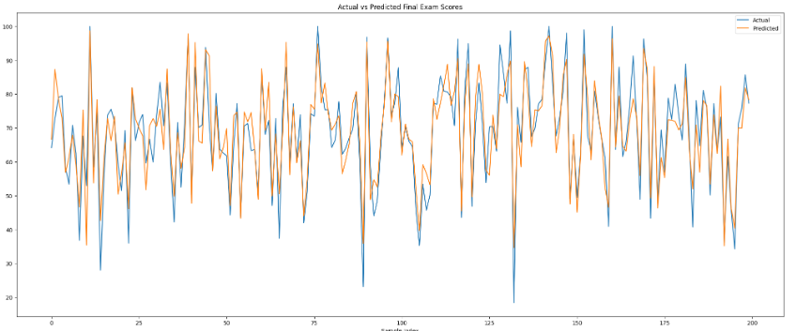

**Use Cases**

* A school counselor can use this model to identify students at risk.
* Students can receive personalized habit improvement recommendations.
* Educational platforms can integrate this insight to provide feedback and nudges.